**Robot Engineering 2. Hafta**

**Robot**

Electromechanical device with

Multiple DOF

Programmable to accomplish a variety of tasks

**Manipulator**

Capable of interacting with the environment

**End Effector**

Mounts to manipulator’s end

Does the job that wanted to be done

Mechanical, magnetic and adhesive grippers, spot-welding tools etc..

Can reach both in position and orientation

**Singularity (Tekillik)**

This is condition in which the manipulator loses one or more degrees of freedom and change in joint variables does not result in change in end effector location and orientation variables. A kinematic singularity is a point within the robot's workspace where the robot's Jacobian matrix loses rank. The Jacobian is the matrix relating joint velocities to end effector velocities.

**How to measure :** This is a case when the determinant of Jacobian matrix is zero ie. It is rank deficit.

**2 DOF types:** Prismatic (ileri geri), Revolute (dönme hareketi, rulman vs.)

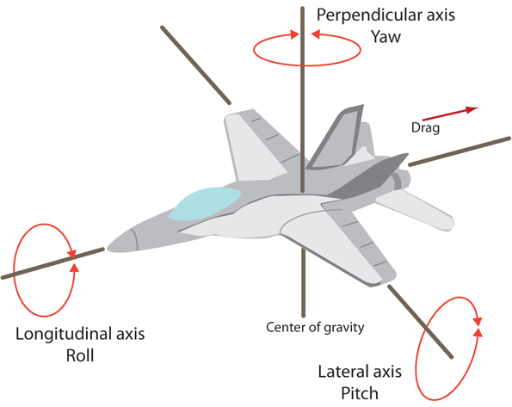**Position:** Translational location of something.

**Orientation:** Rotational location of something.

**Kinematics**

Study of motion without regard to forces.

**Dynamics**

Study of motion regard to forces.

**Actuator**

Provides the force to get a motion.

**Sensors**

Read variables in robot motion for use in control.

**Power Sources**

Hydraulic , electric, pneumatic drivers

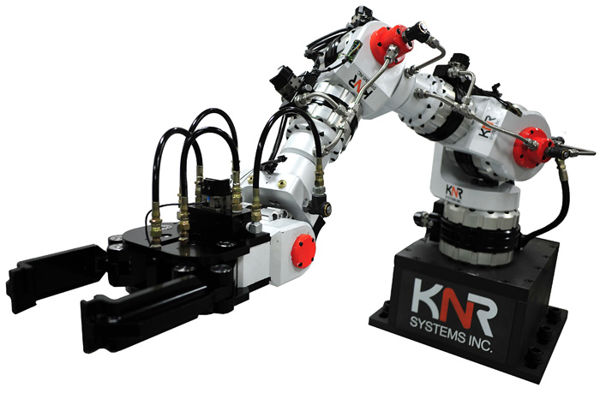**Hydraulic Driver**

**Pros;**

Provides fast movement

For heavy parts

For using in explosive environment

**Cons;**

Occupies large area

There is a danger of oil leak

**Electric Driver**

**Pros;**

Good for small and medium sized robots

Better positioning and accuracy

**Cons;**

Slower movement compared to hydraulic robots

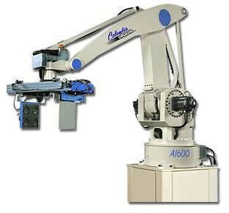

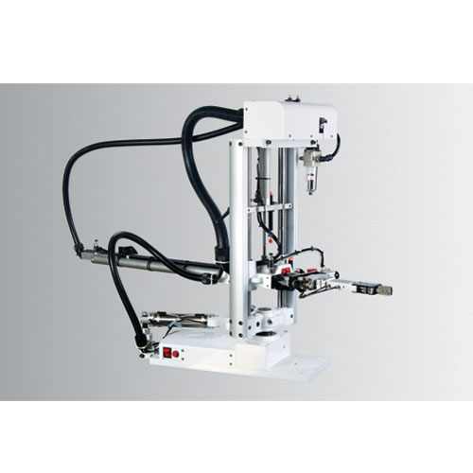**Pneumatic Driver**

**Pros;**

Preferred for smaller robots

Less expensive than hydraulic or electric robots

Suitable for simple pick and place

**Cons;**

Lack of providing force for heavy duties

**Sensors**

There are sensors that measures the position, range, velocity etc.

***Velocity Sensor:*** It measures the speed when the manipulator is moved. The velocity is important for dynamics.

**Contradiction trade-off**: There is an inverse ratio between stability and the speed of response.

**Stability**

Refer to robot motion with least amount of oscillatory.

There are two types of control; Point to point (PTP) and Continous motion

Precision of robot movement is defined three basic features;

1. **Spatial Resolution**

Smallest increment of movement the manipulator does.

1. **Accuracy**

Accuracy can be defined as the ability of a robot to position its wrist end at a desired target point within its reach.

1. **Repeatability**

It is the ability of the robot to position the end effector to the previously positioned location.

**Robotic Joint:** A mechanism that permits relative movement between parts of a robot arm.

**Prismatic Joint (L):** Also known as sliding.

**Revolute Joint (R):** Permits only angular. (Rulmanlar)

***Movement types;*** **Rotational:** To place roboti arm any direction on horizontal plane. **Radial**: Moving the end-effector radially to reach distant points. **Vertical**: Takes the end-effector of the robot different heights.

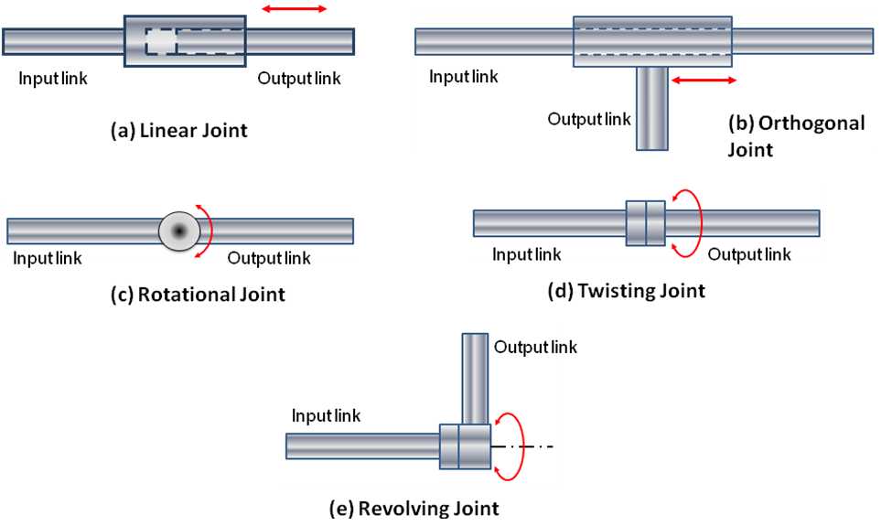

Linear : L, Rotational : R, Twisting : T, Revolving : V

Robots may be classified based on; Control systems and pyshical configurations.

There are 4 types of psyhical configurations;

– 1. Cartesian configuration

– 2. Cylindrical configuration

– 3. Polar configuration

– 4. Joint-arm configuration

**Cartesian**: It consist only linear joints. Gantry robots are cartesian robots (LLL). It commonly used for pick and place work, asembly operations, handling machine tools, arc welding.

***Pros;*** Ability to do straight line insertions, easy computation and programming, most rigid structure for given length

***Cons;*** Requires large operating volume, requires covering in dusty places, can only reach front of itself, axes hard to seal

**Cylindirical**: It consist rotary joint on its base and linear joints for other movements. Commonly used for die casting machines, assembly, handling machine tools, spot welding.

***Pros;*** Can reach all around itself, relatively easy programming, rigid enough to handle heavy loads, good access into cavities and machine openings

***Cons;*** Can’t reach above itself, won’t reach around obstacles, exposed drivers are difficult to cover from dust and liquids